**Practical No: 7**

**Name :- Jayant Sanjay Patil**

**Practical Name: Use git branch to create a new branch and git checkout to switch branch.**

**Roll No: 45**

comp@com135 MINGW64 ~

$ git clone https://github.com/Shitu18/KBCNMU.git

Cloning into 'KBCNMU'...

remote: Enumerating objects: 3, done.

remote: Counting objects: 100% (3/3), done.

remote: Total 3 (delta 0), reused 0 (delta 0), pack-reused 0

Receiving objects: 100% (3/3), done.

comp@com135 MINGW64 ~ (master)

$ cd KBCNMU

comp@com135 MINGW64 ~/KBCNMU (main)

$ git init

Reinitialized existing Git repository in C:/Users/comp/KBCNMU/.git/

comp@com135 MINGW64 ~/KBCNMU (main)

$ git branch branch2

comp@com135 MINGW64 ~/KBCNMU (main)

$ git checkout branch2

Switched to branch 'branch2'

comp@com135 MINGW64 ~/KBCNMU (branch2)

$ touch srp.txt

comp@com135 MINGW64 ~/KBCNMU (branch2)

$ git add srp.txt

comp@com135 MINGW64 ~/KBCNMU (branch2)

$ git commit -m "This is 7th practical"

[branch2 099e96e] This is 7th practical

1 file changed, 0 insertions(+), 0 deletions(-)

create mode 100644 srp.txt

comp@com135 MINGW64 ~/KBCNMU (branch2)

$ git push -u origin branch2

Enumerating objects: 4, done.

Counting objects: 100% (4/4), done.

Delta compression using up to 4 threads

Compressing objects: 100% (2/2), done.

Writing objects: 100% (3/3), 286 bytes | 143.00 KiB/s, done.

Total 3 (delta 0), reused 0 (delta 0), pack-reused 0

remote:

remote: Create a pull request for 'branch2' on GitHub by visiting:

remote: https://github.com/nikhild/KBCNMU/pull/new/branch2

remote:

To https://github.com/Shitu18/KBCNMU.git

* [new branch] branch2 -> branch2

branch 'branch2' set up to track 'origin/branch2'.

comp@com135 MINGW64 ~/KBCNMU (branch2)

$ git branch --list

* branch2

main

comp@com135 MINGW64 ~/KBCNMU (branch2)

$ git checkout main

Switched to branch 'main'

Your branch is up to date with 'origin/main'.

comp@com135 MINGW64 ~/KBCNMU (main)

$ git branch -d branch2

warning: deleting branch 'branch2' that has been merged to

'refs/remotes/origin/branch2', but not yet merged to HEAD.

Deleted branch branch2 (was 099e96e).

comp@com135 MINGW64 ~/KBCNMU (main)

$ git branch --list

* main

**Before pull and merge on remote repository:-**

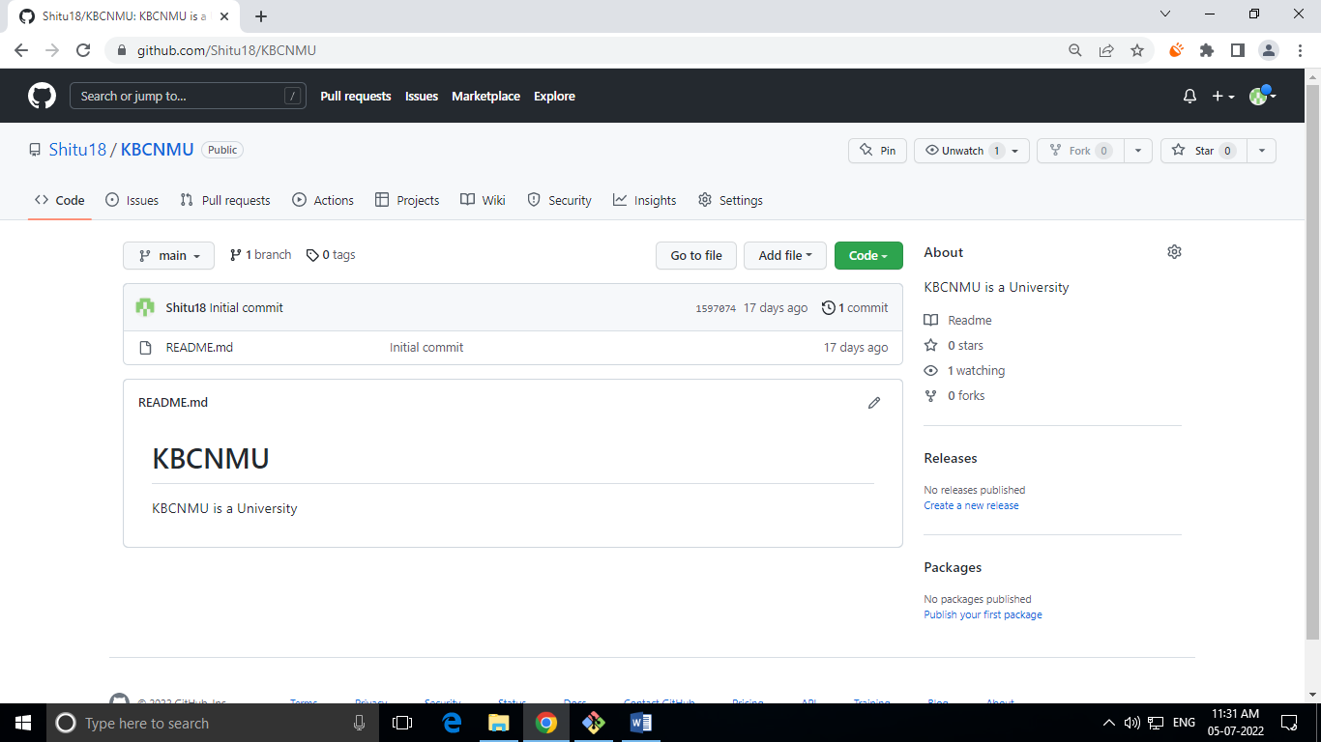

**Performing pull request:-**

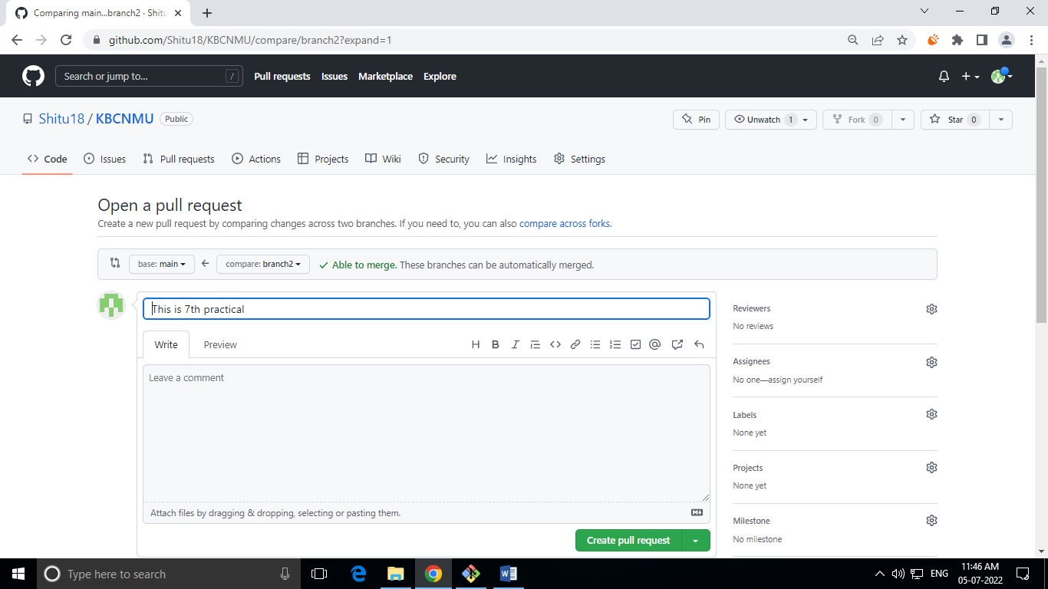

**After pull performing merge on repository at a primary branch (main):-**

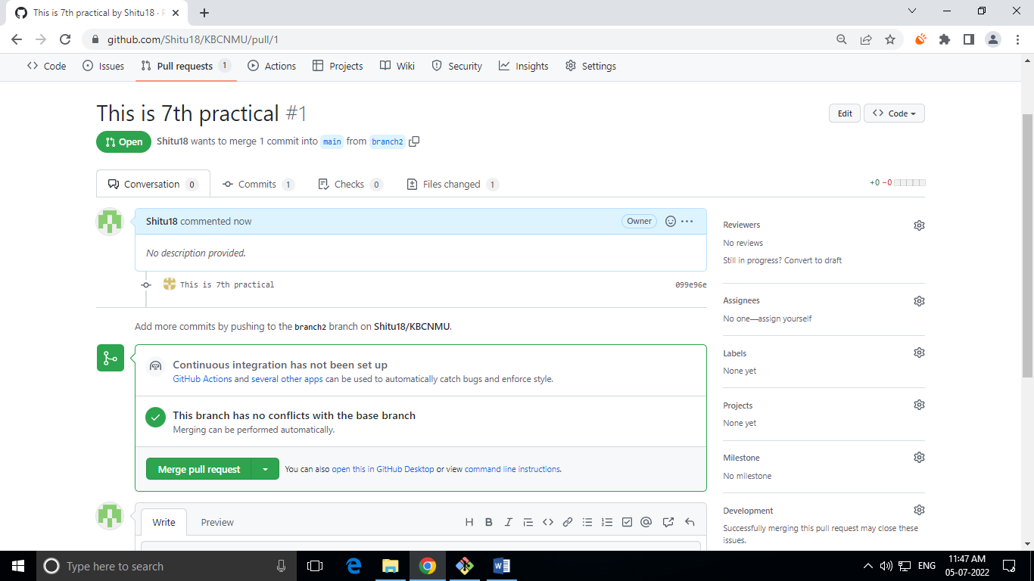

**After Merge from branch2 to primary (main) on remote repository:-**

